(Approx. 965 words)

Musings of an Apple Tyro
Setting Up a New Computer
By Lorrin R. Garson, Potomac Area Technology and Computer Society
May 2016 issue, PATACS Posts
www.patacs.org
newslettercolumnist (at) patacs.org

Buying a new computer isn’t like buying a new car—turn on the engine and go. No! No! This applies to any type of computer, Apple, Windows or Linux. That new computer out of the box is quite vulnerable. Here are some suggestions to protect your new machine and you.

- Be sure your new system is connected to the Internet.
- You need to install the latest operating system updates. Depending on how long your new machine sat on the store’s shelf this can take just a few or many minutes.
- Install a second Web browser. Computers come with a browser (Safari for Apple, Internet Explorer or Microsoft Edge for Windows), but you need at least two browsers. Why? If a single browser gets badly corrupted or deleted, how are you going to recover the browser without a browser? Firefox, Chrome and Opera are good choices and there are numerous others.
- Time to install anti-virus software… or not. For Windows systems, it’s essential. Windows Defender comes with new Windows machines, but sometimes PC makers turn it off and install trialware for a premium security product like Norton or McAfee. Turn on Defender or the trialware and, if you think appropriate, buy the premium package soon. For Apple computers, most home users don’t install anti-malware software, but this is a somewhat controversial issue. There is numerous free anti-malware software for Windows, Apple and Linux systems.
- Clean out the bloatware. This applies to machines from big-name PC makers but not Apple or Linux computers. PC Decrapifier (“…it’s like TP for your PC”) has good reviews and is available from https://www.pcdecrapifier.com/. CCleaner is another respected tool (see http://www.piriform.com). Be sure to create a restore point before running these program, just in case.
- If appropriate, transfer your files from the old computer to the new machine. If you have switched operating systems this will be more challenging, although ordinary files (Microsoft Office, pictures, etc.) are generally straightforward to move.
- Implement backup. Hopefully before purchasing your new machine you decided on a backup plan and acquired the necessary software and an external storage device or two. Remember, disk drives have a significantly higher failure rate the first year than in the next 2-3 years.
- Acquire and install your “must have” software. Hopefully here also you have planned ahead for what you need. Don’t forget a password manager.

At this point you should be good to go, but you’ll spend the next several weeks fine tuning your new computer environment.

Gargantuan Disk Drives
Perhaps with your new computer you need a lot of storage. Consider buying Seagate’s 8 TB hard drive for $385. See http://bit.ly/1Q2AjrO. If that isn’t enough you can plunk down an estimated $13,000 for a 13 TB SSD drive from Fixstars. See http://bit.ly/1nnnwXS. Very few people are going to need anything like this capacity, but this shows how storage capacity is growing.

Troubleshooting Wi-Fi
Occasionally we all experience Wi-Fi problems. Frequently just turning off the power to routers and switches, waiting a bit, then turning devices back on solves the problem. But when this doesn’t do the trick, OS X on Macs has a nifty diagnostic tool most users don’t know about. To access this tool, hold down the “option” key and left-click on the wireless icon () on the Finder menu. This will display the panel shown in Figure 1 below.
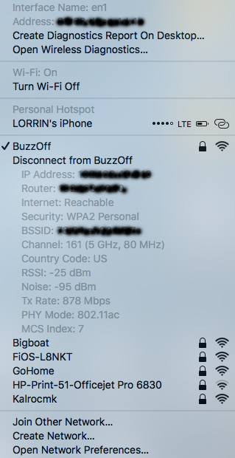
Figure 1
Two particularly telling values will often indicate if you are having a problem, specifically:
- Tx Rate (878 Mbps in this case) which is the actual speed at which data is being transmitted between your access point and your computer.
- RSSI (25 dBm). This is the “Received Signal Strength Indication” which shows the strength of your signal. The closer to zero the better.
Left-clicking on “Create Diagnostics Report On Desktop…” and “Open Wireless Diagnostics…” will generate much detailed analytical information.
It is suggested you experiment with this tool when not experiencing a problem to understand what values are associated with normal operation.
Also see http://bit.ly/1SiQcOF and http://bit.ly/1SiQxRr
Mactracker
On occasion it can be challenging to find information for a specific Apple product. Mactracker, free from the Apple’s App Store, to the rescue. This Application can provide detailed information on every Mac computer ever made as well as information on Apple mice, keyboards iPads, etc. For example, in Figure 2 is the information an iMac 21.5-inch, late 2013 under the “General” tab.

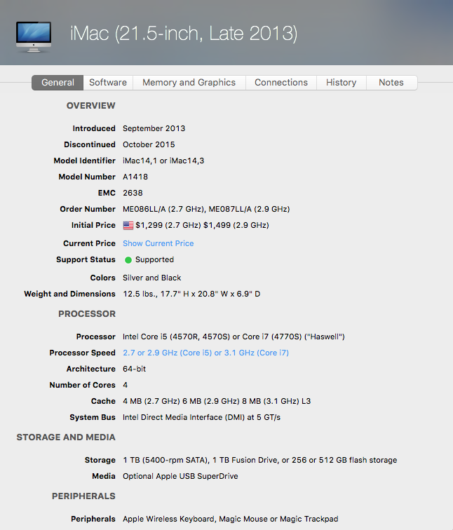
Figure 2
Swift Available for Linux
Apple made its Swift programming language open-source some time ago, but now has made it available for Linux (Ubuntu 15.10 and 14.4). This won’t have a direct impact on 99.9+% of home users. This move is aimed toward the Linux server market. Many servers use Linux as their OS. Apple benefits by getting developers to improve Swift with their suggestions and by enticing developers to adopt Swift aims to get developers to create software for OS X and iOS. Who knows, Swift may be available for Windows and Android some day. See http://bit.ly/20qmXsE.

It can be done, but not easily. See http://bit.ly/1o1I2gt for “How to Get Online Without Using a Browser”.
If you are moving from one operating system to another, careful planning is essential. Although generally for most applications there will be a functional equivalent on your new machine, the software on your old computer may not be available on the new. Transferring data from one application to another can be challenging and sometimes unworkable, even if a different operating system isn’t involved.
For security and privacy, IP address and other sensitive information has been obliterated.

